**Unit 0 – Introduction**

Answer the questions and complete the programs in preparation for the end of Unit exam

**Review Questions:**

1. Explain the difference between using a computer program and programming a computer.
2. Which part of a computer can store program code? Which can store user data?
3. Explain two benefits of using Java over machine code.
4. On your own computer or on a lab computer, find the exact location(folder or directory name) of
   1. The HelloPrinter.java file that we wrote with Eclipse
5. How do you discover syntax errors? How do you discover logic errors?

**Exercises:**

1. Write a program that will print your name in a box on the screen like this:

Mr. Remington

1. Write a program that will print an image. (house, face, animal)

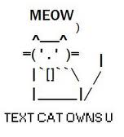

1. Write a program that prints the United States flag, using * and = characters